**Лабораторна робота № 8. Списки**

***Мета:*** одержати навички та закріпити знання при виконанні операцій на списках.

**1 Вимоги**

**1.1 Розробник**

* Макаренко Владислав Олександрович
* Студент 1-го курсу
* Групи КІТ-120а

**1.2 Загальне завдання**

Передбачити такі функції:

* додавання елементів у список та підсписок (при додаванні елемента у головний список дадається і відповідний підсписок);
* видалення елементів зі списку та підсписків (при видаленні елемента з головного списка видаляється і пов’язаний з ним підсписок);
* видачк вмісту списків та підсписків у консоль;
* видалення списків.

**1.2 Загальне завдання**

**Список** Назви країн

**Підсписок** Міста країни

**2 Описи програм**

**Код програми**

#include <iostream>  
#include <string>  
  
using namespace std;  
  
struct CityElement{  
  
 CityElement *next;  
 string name;  
};  
  
struct CityList {  
  
 CityElement *head;  
};  
  
struct CountryElement{  
  
 CityList *cities_list;  
 CountryElement *next;  
 string name;  
};  
  
struct CountriesList{  
  
 CountryElement *head;  
};  
  
void InitCountryList(struct CountriesList &*country_list*){  
  
 *country_list*.head = new struct CountryElement;  
 *country_list*.head->next = NULL;  
}  
  
void AddCountry(struct CountriesList &*country_list*, string *name*){  
  
 struct CountryElement *new_country = new struct CountryElement;  
 new_country->name = name;  
 new_country->next = NULL;  
 new_country->cities_list = NULL;  
 struct CountryElement *current_last = *country_list*.head->next;  
 if (current_last == NULL)  
 *country_list*.head->next = new_country;  
 else  
 {  
 while (current_last->next != NULL)  
 {  
 current_last = current_last->next;  
 }  
 current_last->next = new_country;  
 }  
}  
  
void AddCity(struct CountriesList &*country_list*, string *country_name*, string *name*){  
  
 struct CountryElement *current = *country_list*.head->next;  
 while (current->name != country_name)  
 {  
 current = current->next;  
 if (current == NULL)  
 {  
 cout << "Not country with name " << country_name << endl;  
 return;  
 }  
 }  
 if (current->cities_list == NULL)  
 {  
 current->cities_list = new struct CityList;  
 current->cities_list->head = new struct CityElement;  
 current->cities_list->head->next = NULL;  
 }  
 struct CityElement *new_city = new struct CityElement;  
 new_city->next = NULL;  
 new_city->name = name;  
 struct CityElement *current_handed_over_object = current->cities_list->head->next;  
 if (current_handed_over_object == NULL)  
 {  
 current->cities_list->head->next = new_city;  
 }  
 else  
 {  
 while (current_handed_over_object->next != NULL)  
 {  
 current_handed_over_object = current_handed_over_object->next;  
 }  
 current_handed_over_object->next = new_city;  
 }  
}  
  
void DeleteCountry(struct CountriesList &*country_list*, string *country_name*)  
{  
 struct CountryElement *deleted = *country_list*.head->next;  
 struct CountryElement *prev = *country_list*.head->next;  
 if (deleted == NULL)  
 {  
 cout << "Not country with name " << country_name << endl;  
 return;  
 }  
 while (deleted->name != country_name)  
 {  
 prev = deleted;  
 deleted = deleted->next;  
 if (deleted == NULL)  
 {  
 cout << "Not country with name " << country_name << endl;  
 return;  
 }  
 }  
 if (deleted == *country_list*.head->next)  
 *country_list*.head->next = deleted->next;  
 else  
 {  
 prev->next = deleted->next;  
 }  
  
 struct CityElement *current_city = NULL;  
 if (deleted->cities_list != NULL)  
 {  
 if (deleted->cities_list->head != NULL)  
 {  
 current_city = deleted->cities_list->head->next;  
 }  
 }  
  
 if (current_city != NULL)  
 {  
 struct CityElement *deleted_handed_over_object_element = current_city;  
 while (current_city != NULL)  
 {  
 current_city = current_city->next;  
 delete (deleted_handed_over_object_element);  
 deleted_handed_over_object_element = current_city;  
 }  
 if (deleted->cities_list->head != NULL)  
 delete (deleted->cities_list->head);  
 if (deleted->cities_list != NULL)  
 delete (deleted->cities_list);  
 }  
 delete (deleted);  
}  
  
void DeleteCityFromCountry(struct CountriesList &*country_list*, string *country_name*, string *city_name*)  
{  
 struct CountryElement *country_from_deleted = *country_list*.head->next;  
 if (country_from_deleted != NULL)  
 {  
 while (country_from_deleted->name != country_name)  
 {  
 country_from_deleted = country_from_deleted->next;  
 if (country_from_deleted == NULL)  
 {  
 cout << "No country with name: " << country_name << endl;  
 return;  
 }  
 }  
 if (country_from_deleted->cities_list != NULL)  
 {  
 struct CityElement *deleted_city = country_from_deleted->cities_list->head->next;  
 struct CityElement *prev = NULL;  
 while (deleted_city->name != city_name)  
 {  
 prev = deleted_city;  
 deleted_city = deleted_city->next;  
 if (deleted_city == NULL)  
 break;  
 }  
 if (deleted_city != NULL)  
 {  
 if (deleted_city == country_from_deleted->cities_list->head->next)  
 {  
 country_from_deleted->cities_list->head->next = deleted_city->next;  
 }  
 else  
 {  
 prev->next = deleted_city->next;  
 }  
 delete (deleted_city);  
 }  
 else  
 {  
 cout << "Not city in country: " << country_name << " with name: " << city_name << endl;  
 return;  
 }  
 }  
 else  
 {  
 cout << "Not city in country: " << country_name << " with name: " << city_name << endl;  
 return;  
 }  
 }  
 else  
 {  
 cout << "Not country with name: " << country_name << endl;  
 }  
}  
  
void DeleteCountriesList(struct CountriesList &*country_list*)  
{  
 struct CountryElement *current = *country_list*.head->next;  
 if (current != NULL)  
 {  
 while (current != NULL)  
 {  
 string deleted_name = current->name;  
 current = current->next;  
 DeleteCountry(country_list, deleted_name);  
 }  
 }  
 delete (*country_list*.head);  
 delete (&*country_list*);  
}  
  
void PrintCountriesList(struct CountriesList &*country_list*)  
{  
 struct CountryElement *current_country = *country_list*.head->next;  
 if (current_country == NULL)  
 {  
 cout << "Not countries" << endl;  
 }  
 else  
 {  
 while (current_country != NULL)  
 {  
 cout << "Country: " << current_country->name << endl;  
 if (current_country->cities_list != NULL)  
 {  
 if (current_country->cities_list->head != NULL)  
 {  
 struct CityElement *current_city = current_country->cities_list->head->next;  
 if (current_city != NULL)  
 {  
 cout << "Cities: " << endl;  
 while (current_city != NULL)  
 {  
 cout << "- " << current_city->name << endl;  
 current_city = current_city->next;  
 }  
 }  
 }  
 }  
 current_country = current_country->next;  
 }  
 }  
}  
  
int main()  
{  
 struct CountriesList *country_list = new struct CountriesList;  
 InitCountryList(*country_list);  
 AddCountry(*country_list, "Ukraine");  
 AddCountry(*country_list, "USA");  
 PrintCountriesList(*country_list);  
 cout << endl << "Add cities: " << endl;  
 AddCity(*country_list, "Ukraine", "Kharkiv");  
 AddCity(*country_list, "Ukraine", "Kiev");  
 AddCity(*country_list, "Ukraine", "Lviv");  
 AddCity(*country_list, "USA", "Washington");  
 AddCity(*country_list, "USA", "California");  
 PrintCountriesList(*country_list);  
 cout << endl << "Delete the country:" << endl;  
 DeleteCountry(*country_list, "USA");  
 PrintCountriesList(*country_list);  
 cout << endl << "Delete the city:" << endl;  
 DeleteCityFromCountry(*country_list, "Ukraine", "Lviv");  
 PrintCountriesList(*country_list);  
 AddCountry(*country_list, "England");  
 cout << endl << "Add country: " << endl;  
 PrintCountriesList(*country_list);  
 cout << endl << "Delete the list:" << endl;;  
 DeleteCountriesList(*country_list);  
 PrintCountriesList(*country_list);  
 return 0;  
}

**Результати виконання програми**

За алгоритмом коду демонструємо роботу програми (див. рис. 1).

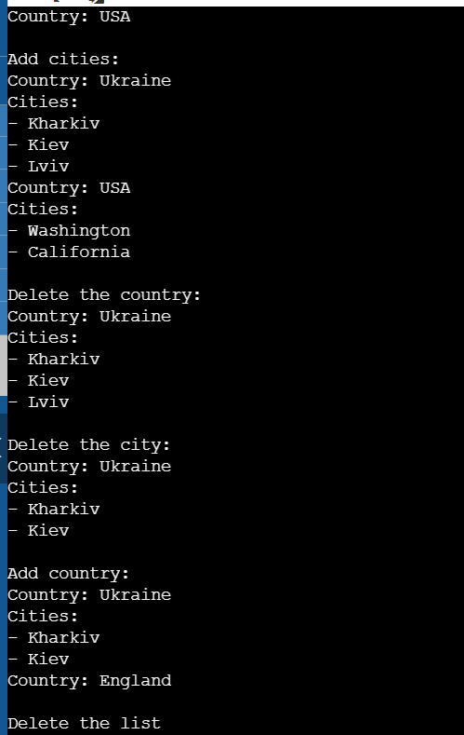

Рисунок 1 – Результати роботи першого кроку

**Висновок:** на цій лабораторній роботі ми одержали навички та закріпили знання при виконанні операцій на списках.